Welcome to 1st Grade
I am excited to welcome you into 1st grade!
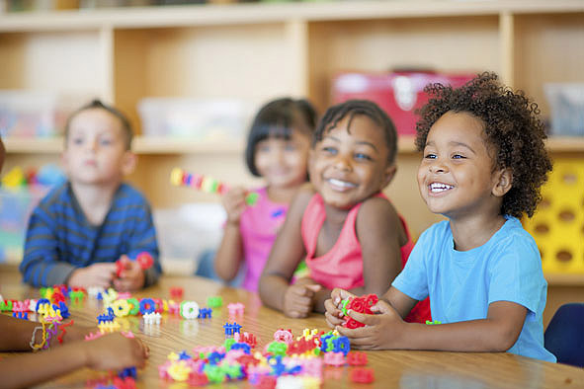

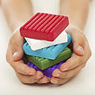

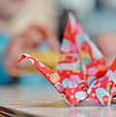
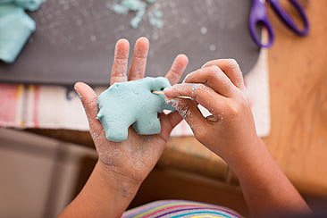

1st grade is a big step for our students. They will beginning to recognize the structure of sentences. Spelling will become more enhanced for them. Plus reading will start picking up and they will be blending words to be able to sound out larger words. Writing will become easier also as they learn how to spell more words and form all letter. 1st grade is a Big year and I am excited to spend it with your children.

Reward System
Classroom treasure box for students who make good choices all week.

Volunteers
Our classroom would always love to have volunteers. Please let me know interested

Special Classes
Schedule will be on website.

Take home folders
Each student will get a blue folder with a side labeled take home and one labeled bring back to school. Please send this back to school daily.

Reading bags
Each student will bring home a reading bag with a book(s) to read 2-3 nights a week. Please read books and sign sheet and return to school.
Contact Information
Mrs. Rives

Classroom Overview
Responsible, Respectful, Safe
Rules and Consequences
We will go over classroom rules the first week of school many times with the students and a follow up letter will be sent home.

Parent/ Guardian Information

Name:____________________________________
Phone:____________________________________
Email:____________________________________
Comments:____________________________________________________________________________________________________________________________________________________________________________________________________________________________________________________________________________________________
Mrs. Rives

